IFRS 9 Week 4 Notes
Week 4 focus: staging, significant increase in credit risk (SICR), acquisition vs behavior PD, month on books, point-in-time PD, through-the-cycle PD, and the ECL formula.

IFRS 9 is the accounting framework for provisioning. It answers a simple question: how much expected credit loss should the bank recognise now? Basel serves a different purpose. It is about capital adequacy and holding capital for unexpected losses.
The week’s discussion stays close to the borrower journey: delinquency, sustained delinquency, default, staging, and then expected credit loss.
Framework | Main job | Simple meaning
Basel | Capital adequacy | How much capital should be held for unexpected loss?
IFRS 9 | Provisioning | How much expected credit loss should be booked now?
CECL | US expected-loss provisioning | The US counterpart in the expected-loss world.
Analogy: Basel is the safety wall, IFRS 9 is the rainy-day fund, and CECL is the US version of the same loss-recognition logic.

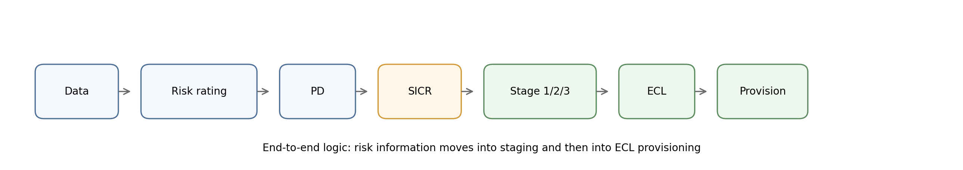
Figure 1. End-to-end IFRS 9 logic from risk information to provision.

Delinquency starts when a borrower misses a payment date. Default is a more serious failure point. Impairment is the accounting conclusion that the exposure has become credit impaired and needs stronger provisioning.
Term | Plain meaning | Credit-risk implication
Delinquency | A payment is missed | The borrower may still cure
Default | Serious credit failure | Recovery becomes uncertain
Impairment | Expected loss is now material | Provisioning becomes more conservative
Charge-off | Policy-driven removal from active book | Collections or recovery may continue
The simple difference matters: delinquency is being late, default is a deeper failure, and impairment is the accounting view of that failure.

Staging is the engine of IFRS 9. Stage 1 covers normal performing accounts. Stage 2 covers accounts with a significant increase in credit risk. Stage 3 covers impaired or default-like accounts.
Stage | Meaning | ECL horizon
Stage 1 | No significant increase in credit risk | 12-month ECL
Stage 2 | SICR triggered | Lifetime ECL
Stage 3 | Impaired / default-like | Lifetime ECL with impairment focus
Stage 1 = healthy borrower. Stage 2 = warning signs. Stage 3 = default-like situation.
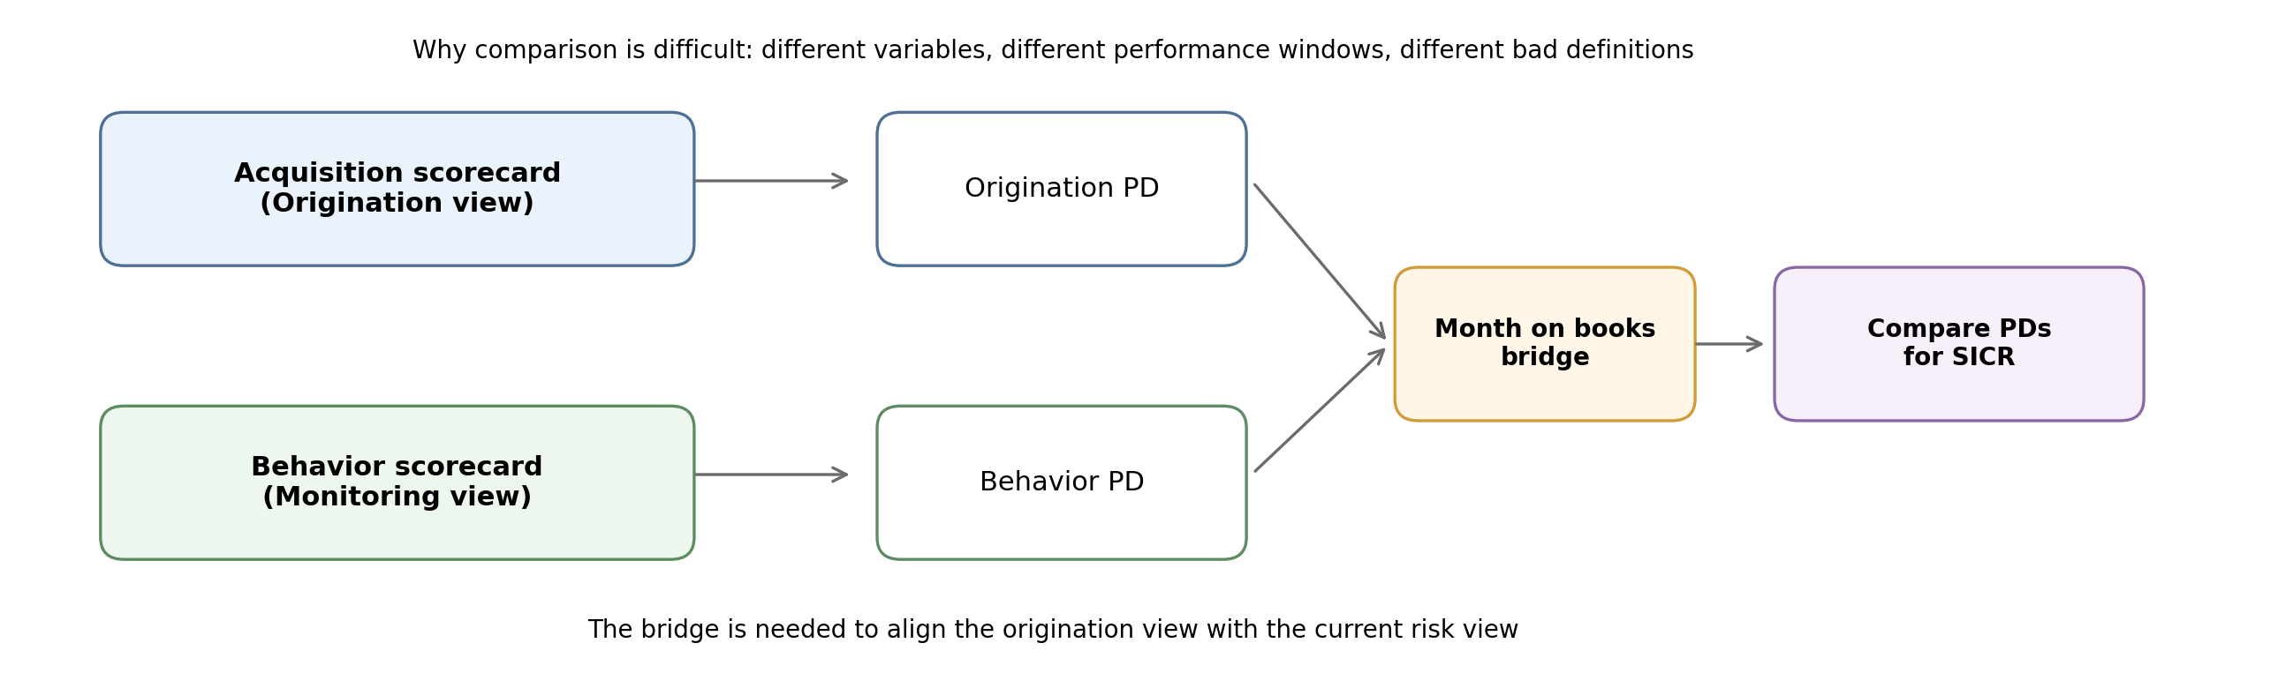
Figure 2. Why acquisition PD and behavior PD need a bridge before they can be compared.

The idea is to compare the borrower’s credit position at origination with the current position. If the current position is materially worse, Stage 1 may move to Stage 2.
SICR lens | What it asks | Why it matters
Relative threshold | Has PD moved by a meaningful percentage? | Useful when starting PDs vary a lot
Hard backstop | Has the borrower crossed a warning rule? | Prevents obvious stress from being missed
Rating migration | Has the internal view deteriorated? | Important in corporate and institutional banking
Committee judgment | Has expert review flagged the account? | Supports model-based staging
In retail-style portfolios, a common backstop is 30 days past due. In many retail portfolios, 90 days past due is the common bad-definition rule; some commercial portfolios can justify a different rule with supporting analysis.

Acquisition scorecards are used at origination. They estimate how likely the new borrower is to be a good borrower. Behavior scorecards are used after booking. They monitor how the same borrower is behaving over time.
The core point is simple: the two scorecards often use different variables, different performance windows, and sometimes different bad definitions. That is why direct comparison is not always clean.
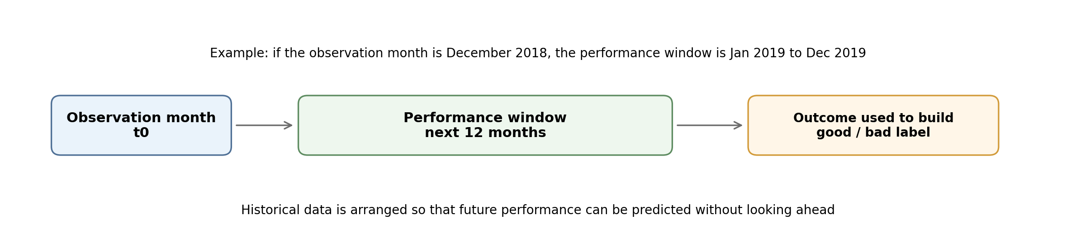
Figure 3. A performance window is built backward from an observation month so that future outcomes can be learned from history.

The comparison is difficult for two reasons. First, the variables are different: origination focuses on reliability and affordability, while behavior focuses on payment conduct and current deterioration. Second, the performance windows can differ, so the labels behind the scorecards may not line up exactly.
Scorecard | Typical focus | Example signals
Acquisition | Reliability and affordability | OD account status, savings balance, FOIR, enquiries
Behavior | How the borrower is paying now | Delinquency pattern, conduct, payment behavior
Bridge | Month on books comparison | Aligns the two views before SICR testing

The logic is not to memorize the numbers mechanically, but to understand what each factor is trying to capture.
Variable | Category in the example | Score | Why it matters
Overdraft account status | No overdraft account | 28 | More reliable conduct
Savings account balance | 0 to 10,000 | 21 | Affordability signal
Other credit | No other credit | 45 | Lower existing burden
Enquiries | 2 enquiries | 28 | Limited credit shopping
Illustrative total score = 28 + 21 + 45 + 28 = 122. The example cut-off used in the session is 107, so this borrower would be accepted.
The scoring logic is a ranking of better and worse borrower profiles. A safer borrower gets a higher score; a riskier borrower gets a lower score.
Analogy
A scorecard is like a bank’s admission test. A stronger profile gets a better score, but the test still needs to be designed around the product and the risk it is trying to measure.

Month on books is the number of months since the account was booked. The key idea is that very early months can still look similar to origination. After some time, the borrower’s actual payment behavior starts to matter more.
Month on books | What it means | Why it is useful
Low MOB | Acquisition and behavior can still look similar | Helps reuse behavior PD as a proxy
Later MOB | Borrower conduct starts to diverge | Behavior PD becomes more informative
Segment level | Cut-off is found for a portfolio segment | Avoids forcing one rule for all accounts
The example uses a small early-month cut-off to align the two PDs. The exact cut-off is not fixed for every account; it is usually studied at a segment level.

IFRS 9 needs a point-in-time PD because provisions must react to current and forecast economic conditions. Basel uses through-the-cycle PD because capital should be more stable and conservative across the business cycle.
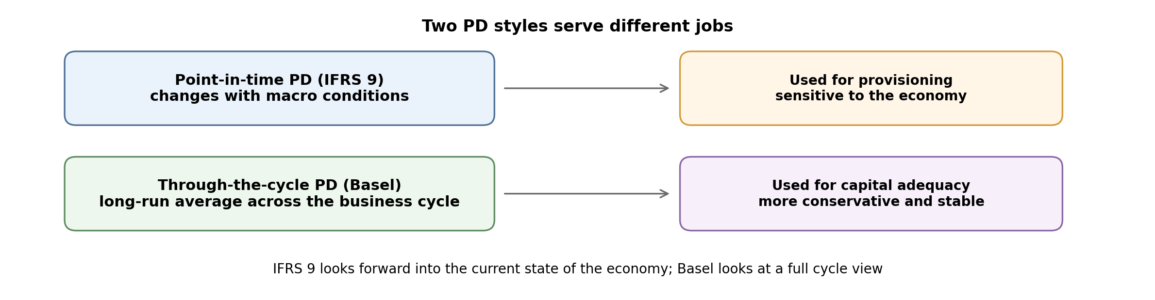
Figure 4. PIT PD moves with the economy; TTC PD smooths across the cycle.
PD type | Used for | Plain reason
Point-in-time PD | IFRS 9 provisioning | Needs to reflect current macro conditions
Through-the-cycle PD | Basel capital | Should stay conservative across the full cycle
In simple words, provisioning is allowed to move with the weather; capital planning should not swing wildly every time the weather changes.

Expected credit loss is presented as PD × LGD × EAD. PD is the chance of default, LGD is the loss severity after recoveries, and EAD is the exposure outstanding at the time of default. For revolving products, the exposure can be more dynamic because credit conversion factors may matter.
Component | Meaning | Simple question
PD | Probability of default | Will the borrower default?
LGD | Loss given default | How much is lost after recovery?
EAD | Exposure at default | How much is outstanding when default happens?
A straightforward worked example was not fully developed in the session, so the formula is the main point to keep from this week.

- IFRS 9 is about expected loss provisioning, not capital adequacy.
- Stage 1 uses 12-month ECL; Stage 2 and Stage 3 use lifetime ECL.
- SICR is the bridge from Stage 1 to Stage 2.
- Acquisition PD and behavior PD often need a month-on-books bridge before they can be compared.
- IFRS 9 uses point-in-time PD because provisioning must react to macro conditions.
- Basel uses through-the-cycle PD because capital should remain conservative across the full cycle.

